EENG 385 - Electronic Devices and Circuits

BJT Curve Tracer: Calibration

Lab Document

**Objective**

The objective of the lab is to introduce the behavior of a transistor and how the how the BJT curve tracer draws the family of *Ic vs. Vce* curves on an oscilloscope in X/Y mode. Finally, we wil calibrate the BJT curve tracer in order to quantify the information displayed on the oscilloscope.

# Overview

Within the lab, you will complete the construction and calibration of the BJT curve tracer, a circuit using an oscilloscope in X/Y mode to display the family of curves shown in Figure 1 (right) for a BJT acting as the device under test (DUT) Figure 1 (left).

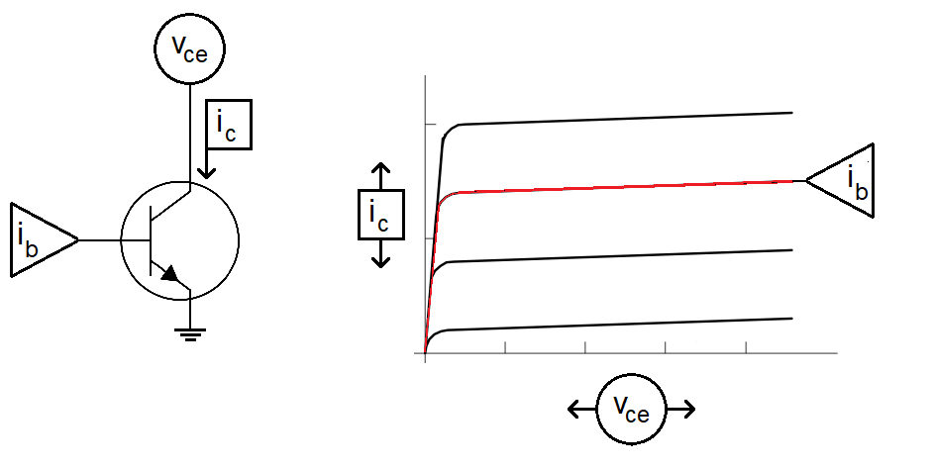

Figure : (Left) The signals needed to generate the characteristic family of curves for a BJT under test include Ib, the base current, Ic the collector current, and Vce the collector emitter voltage. (Right) The family of Ic vs. Vce curves as drawn on the oscilloscope.

To generate the red curve in Figure 1 (right), we need to complete the following 3 plotting tasks:

1. Set the base current to the red value in Figure 1 (right).
2. Then, sweep the collector emitter voltage from 0V to 5V.
3. Then, while doing the sweep, measure the collector current.

Fortunately, we have built most of the circuits needed to accomplish the task in the previous labs. These circuits interface with the DUT and the current mirror shown in Figure 2 to generate the signals shown in Figure 1.

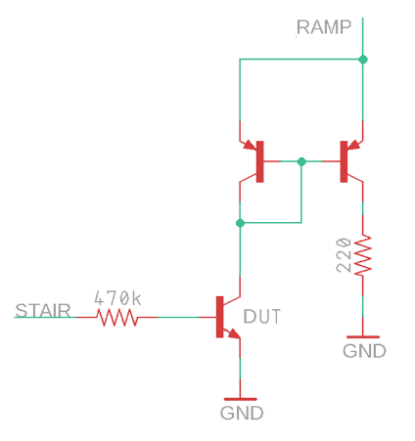

Figure : The output stage of the BJT curve tracer uses a current mirror to measure the collector current.

The list of plotting tasks is reframed in terms of the circuit shown in Figure 2 as:

1. The STAIR voltage is fed into the base of the DUT through a 470 kΩ resistor, setting the base current.
2. The collector emitter voltage of the DUT sweeps from 0V to 5V using the output of the pseudo ramp generator.
3. The collector current of the DUT is indirectly measured, through the current mirror, as the voltage across a 220 Ω resistor.

Now, a way to plot the collector emitter voltage against the collector current is needed. This need is where the X/Y mode of the oscilloscope comes into its own.

# Oscilloscope in X/Y Mode

You have mainly used oscilloscopes in time-base mode, meaning the voltage on Channel 1 is plotted vs. time. You can imagine the voltage on Channel 1 controls the height of the beam as the beam is being swept across the display. In X/Y mode, the oscilloscope uses the voltage on Channel 1 to control the horizontal position (x-axis) of the beam and, at the same time, uses the voltage on Channel 2 to control the vertical position (y-axis) of the beam.

At first, this interaction sounds really weird and counter intuitive. However, you can do some pretty useful things with an oscilloscope in X/Y mode, like drawing the family of curves for a BJT. To explore this idea further, let’s work the following example. Use the voltages on Channel 1 and 2 in Figure 3 to determine what is displayed with the oscilloscope is X/Y mode. In this example, the following conditions are set.

* Ch 1 is configured to provide x-axis data.
* Ch 2 is configured to provide y-axis data.
* The vertical axis for Ch1 and Ch2 is 1 Volt per division.
* The center horizontal line is set to 0V.

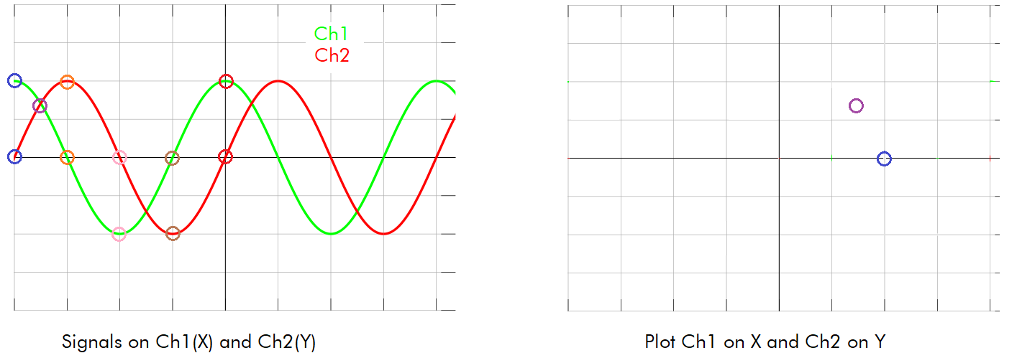

Figure : A pair of signals on Channel 1 and Channel 2. Plot these 2 signals in XY mode.

At the left edge of the screen, the values of Ch 1 and Ch 2 are circled in blue, with Ch 1=2V and Ch 2=0V. So in the right half of Figure 3, a blue circle is placed at (x,y) = (2V, 0V). Note, the X/Y plot has the same scale as its respective channel.

Complete Table 1 by finding the voltages for Channel 1 and Channel 2 at the indicated times. Then, place these points on the X/Y plot, connect the dots, and determine what the user would see. The key to determining the scales of the X- and Y-axis in Figure 4 is the circuit which drives the X and Y signals, shown in Figure 5.

Table : The X,Y values of the curve in Figure 3.

|  |  |  |
| --- | --- | --- |
| **Time** | **Ch 1 (X)** | **Ch 2 (Y)** |
| Blue | 2 | 0 |
| Purple | 1.4 | 1.4 |
| Orange | 0 | 2 |
| Pink | -2 | 0 |
| Brown | 0 | -2 |
| Red | 2 | 0 |

# Axis Scale for BJT Curve Tracer

We need a way to convert the picture shown on the oscilloscope into numerical data informing us of the operation of the BJT. You will quantify the picture on the oscilloscope using the grid displayed on the oscilloscope screen and by the scale settings you establish by turning the Ch 1 and Ch 2 vertical scale knobs. Some notation is in order before proceeding.

* Let *VSCALE_X* be the volts per division set with the Ch 1 Vertical scale knob. This number is shown after the yellow “1” in the upper left corner of the oscilloscope screen.
* Let *VSCALE_Y* be the volts per division set with the Ch 2 Vertical scale knob. This number is shown after the green “2” in the upper left corner of the oscilloscope screen.
* Call the distance between the grid lines shown on the oscilloscope face “divisions”.

For example, in Figure 4, *VSCALE_X* = 500 mV/div and *VSCALE_Y* = 200 mV/div. The X1 and X2 cursors are about 8.4 divisions apart.

* 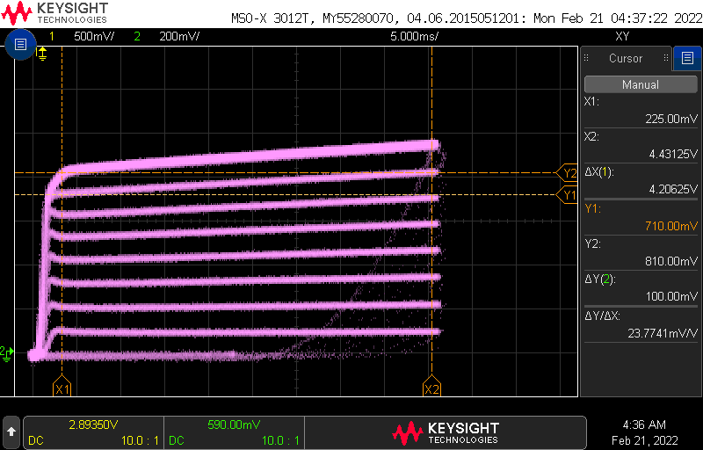

Figure : The oscilloscope display showing the family of curves.

The key to finding an equation allowing us to convert the picture on the oscilloscope screen to numerical values are the circuits which drive the X and Y signals shown in Figure 5.

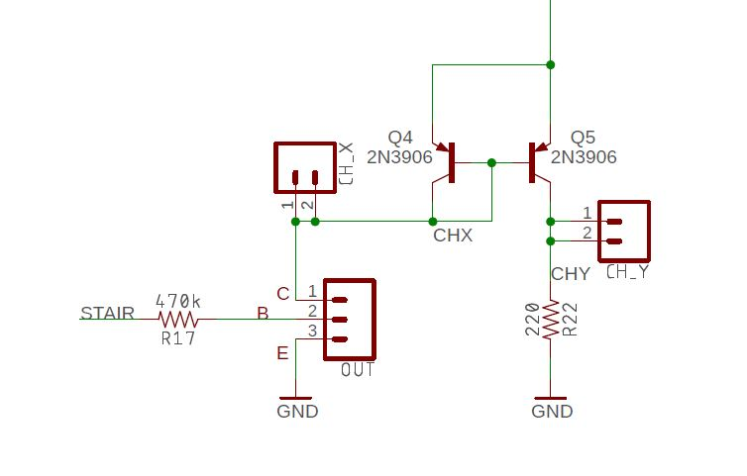

Figure : The circuit generating the 2 channels for the X-Y mode.

Let’s start by examining the Horizontal Axis scale.

**The Horizontal Axis Scale – Collector Emitter Voltage**

You will connect the Channel 1, CH_X, in Figure 5, probe to the collector of the DUT. The scale of Channel 1 is equal to the scale of the horizontal axis. Thus, when Channel 1’s scale is set to 1V per division on the oscilloscope, the horizontal axis on the oscilloscope will show *Vce* at 1V per division. Thus, we have Equation 1:

|  |  |  |
| --- | --- | --- |
|  | Ch1 conversion factor |  |

In order to determine *Vce* of a point on the oscilloscope screen, multiply its horizontal position (in divisions) by *VSCALE_X* and the Ch1 conversion factor. For example, if the voltage of a point is at X divisions, with the scope set to *VSCALE_X* = *Y* volts/div, then *Vce* is given by Equation 2. Notice how the units cancel leading to the final answer in volts.

|  |  |  |
| --- | --- | --- |
|  |  |  |

The discussion surrounding the Horizontal scale equation seems trivial. So, let’s explore the situation on Channel 2 where we will use these same concepts with more complex relationships.

**The Vertical Axis Scale – Collector Current**

You will connect the Channel 2, CH_Y in Figure 5, probe to the output of Q5 that is being run through a 220Ω resistor. Since Q4 and Q5 are arranged as a current mirror, the current output of Q4 sets the current out of Q5. Since the current out of Q4 is the collector current, ic, of the DUT then the current output of Q5 is also equal to *ic*. Thus, the collector current is equal to the current flowing through the 220Ω resistor. The voltage at the CH_Y probe in Figure 5 is found using Ohm’s law and given by Equation 3.

|  |  |  |
| --- | --- | --- |
|  |  |  |

Solving Equation 3 for current over voltage gives the Ch2 conversion factor:

|  |  |  |
| --- | --- | --- |
|  | Ch2 conversion factor |  |

In order to determine *ic* of a point on the oscilloscope screen, multiply its vertical position (in divisions) by *VSCALE_Y* and the Ch2 conversion factor. For example, if the current of a point is at X divisions, with the scope set to *VSCALE_Y = Y* volts/div, then *ic* is given by Equation 5. Notice how the units cancel leading to the final answer in volts.

|  |  |  |
| --- | --- | --- |
|  |  |  |

**Each Curve – Base Current**

The circuit in Figure 5 keeps the DUT transistor in the active region. Thus, the BE junction of the DUT has a 0.7V drop. Since the emitter of the DUT is grounded, this arrangement means the base of the DUT is at 0.7V. Let’s call the voltage at the STAIR signal *VSTAIR*. You can use a combination of KVL and Ohm’s law to compute the voltage drop from *VSTAIR* to ground as:

|  |  |  |
| --- | --- | --- |
|  |  |  |

Solving Equation 6 for *ib* yields Equation 7.

|  |  |  |
| --- | --- | --- |
|  |  |  |

Computing the base current for each value of *VSTAIR* requires you to carefully measure the voltage of each step. Note, you can perform this measurement before soldering in the new components associated with this lab. To get these values, start by powering up your BJT curve tracer board with 9V from the lab power supplies. Next, power up an oscilloscope, attach a probe to Channel 1 and configure the oscilloscope as follows:

|  |  |
| --- | --- |
| Ch1 probe | STAIR test point |
| Ch1 ground clip | GND test point |
| Horizontal (scale) | 1ms |
| Ch1 (scale) | 1V or 2V (whatever fits better) |
| Trigger mode | Auto |
| Trigger source | Ch1 |
| Trigger slope | ↓ |
| Trigger level | 4.5V |

You should get something that looks like the curve in Figure 6.

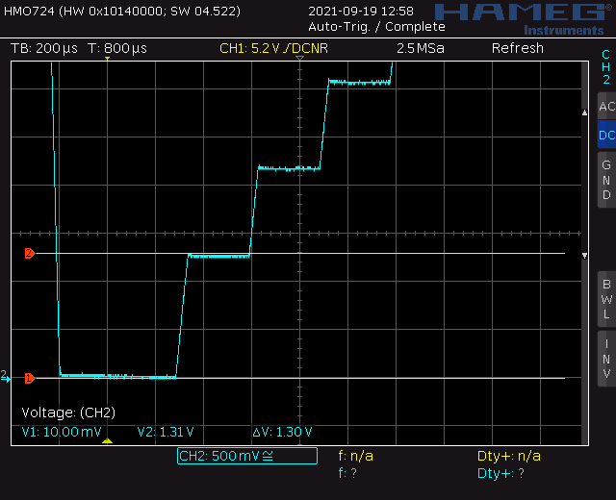

Figure : Measuring the voltage of the first VSTAIR value using cursors to be about 1.3V.

Now, measure the voltage of each step and record the values in the *VSTAIR* column of Table 2. Note, Trace 0 never leaves 0V. Trace 1 is the first trace above Trace 0 and should be around 1.3v. Your values will be different from mine.

Table : The base current for each step of the staircase function.

|  |  |  |
| --- | --- | --- |
| **Trace** | ***VSTAIR*** | ***ib* (µA)** |
| 9 | 8.03 | 15.6 |
| 8 | 7.84 | 15.2 |
| 7 | 6.95 | 13.3 |
| 6 | 6.06 | 11.4 |
| 5 | 5.07 | 9.3 |
| 4 | 4.18 | 7.4 |
| 3 | 3.29 | 5.5 |
| 2 | 2.39 | 3.6 |
| 1 | 1.41 | 1.5 |
| 0 | 0V | 0 |

Now, use the voltages in the ***VSTAIR*** column of Table 2 to compute the base current, ib, using Equation 7. You will need the information in Table 2 every time you run the BJT curve tracer with a DUT. Let’s explore how to use this information to calculate the gain and Early Voltage of the DUT.

# Assemble the BJT Curve Tracer

This week, you will be soldering in the components in the upper right corner of the BJT Curve Tracer PCB, completing the assembly as shown in Figure 7.

* You will need two 2N3906 PNP transistors to populate the Q5 and Q6 positions. Make sure the flat side of the PNP package aligns with the flat side of the PCB silkscreen.
* You will need one 2N3904 to populate the Q2 position in the ST Relax Oscillator area. Make sure the flat side of the PNP package aligns with the flat side of the PCB silkscreen.
* You will need to use the 3-pin header included in your parts bag for the DUT.
* Save the leads from your resistors to solder in the CH_X, XH_Y and GNG loops
* Do not install the 10K resistor hanging over the TLC274 shown in Figure 7. I added this resistor to remove an annoying glitch on an earlier revision of the BJT Curve Tracer that will not occur on your board

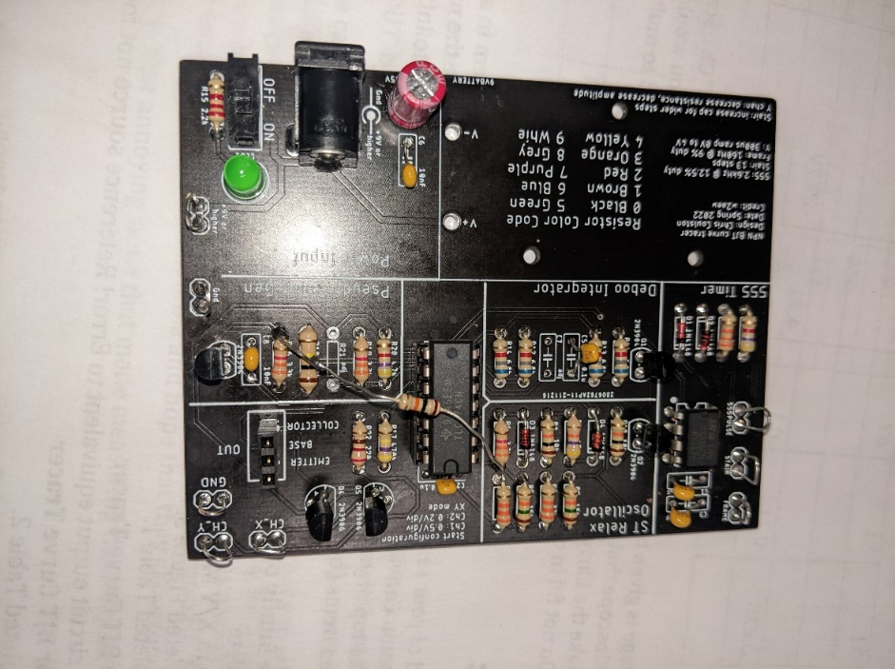

Figure : The completed BJT Curve Tracer board. Do not add the free floating 10K resistor.

Once you have completed soldering in the new components you will notice the amplitude of the FRAME output will drop. The 555PULSE, STAIR, and Pseudo Ramp outputs should be unchanged. Now, test your completed BJT Curve Tracer and get some data.

# Inserting the DUT into the BJT Curve Tracer

You will be measuring the performance of several BJTs in this week’s lab. In order to do so, you will have to insert the leads of the BJT into the correct socket positions as shown in Figure 8C. I orientated the DUT socket with the 2N3904 and 2N2222 BJTs in mind. To see how that effeced the design, look closely at the arrangement of pins in Figure 8A and 7B. Even though the pins are arranged differently, the base is the center pin.

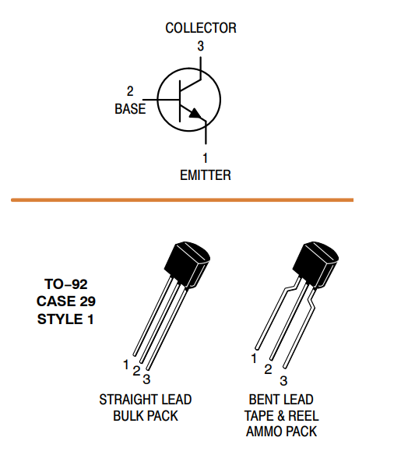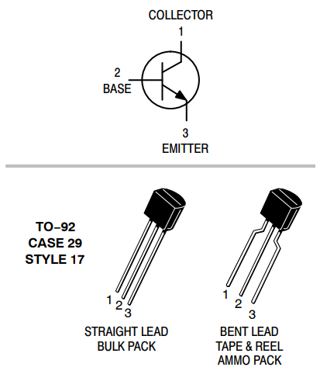 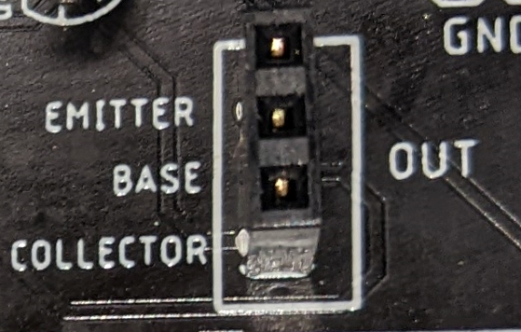

1. (B) (C)

Figure : (A) The datasheet for the 2N3904. (B) The datasheet for the 2N2222. (C) The socket for the DUT – yes that is a typo on the silk screen.

So you have to insert the 2N3904 into the DUT socket so that the BJT’s flat side is facing left. However, you have to insert the 2N2222 into the DUT socket so that the BJT’s flat side is facing right. You will not harm the test BJT if you put it in backwards.

The BJTs shown in Figure 8A and B are encased in JEDEC standard Transistor Outline Package Case Style 92 or TO-92 package. Most BJTs in a TO-92 package have the base as their center pin. This situation makes inserting them into the DUT socket a matter of trying two different orientations. The situation gets more complex for larger packages.

Before continuing, a note about BJT datasheets. Often BJTs are developed in complementary NPN/PNP pairs. For instance, Motorola designed 2N3904 and 2N3906 BJTs. Being designed as complementary pairs, the manufacturers often group the two complementary BJTs on the same datasheet for efficiency. When the manufacturer does this, you only need to look at the NPN device parameters datasheet because you will only be testing NPN devices in the BJT Curve Tracer.

Now, look at the datasheet for the BD139 and TIP41C shown in Figure 9A and 8B.

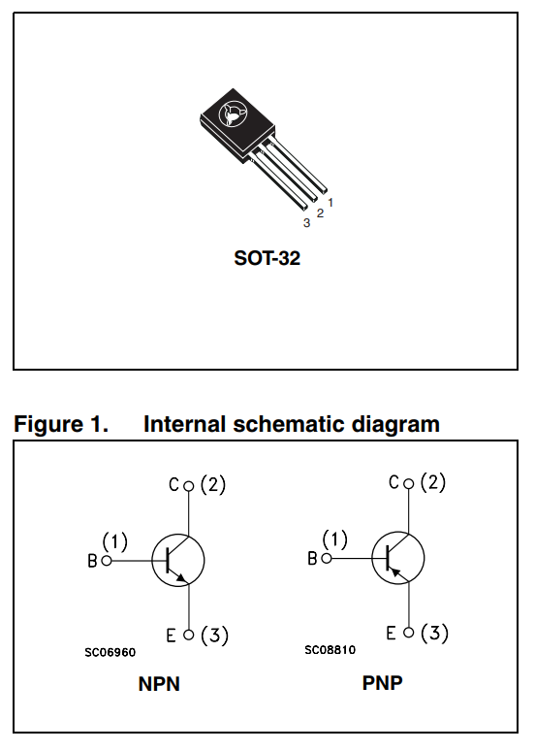 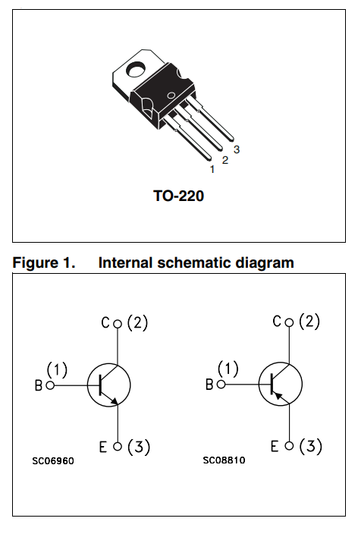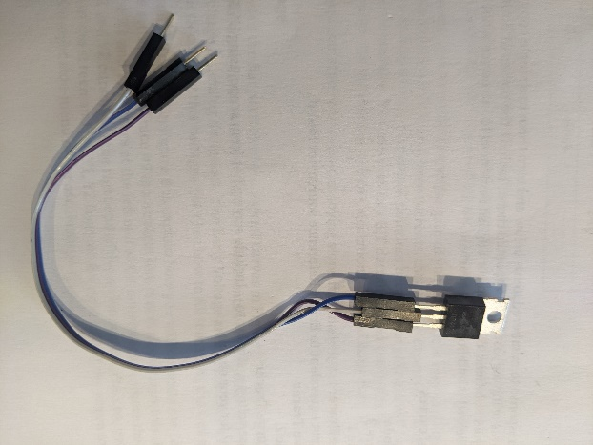

(A) (B) (C)

Figure : (A) The pinout for the BD139 (NPN) and BD140 (PNP). The pinout of the TIP41C (NPN) and TIP42C (PNP). You can use a set of jumper wires to adapt the pins of non-conforming devices to the DUT socket.

In Figure 9A, the NPN device in the Internal Schematic Diagram frame is called out as “NPN”. The base of the schematic symbol is denoted “B” with an accompanying number (1). Looking at the physical package above the schematic, the pin labeled “1” is the base, the rightmost pin on the BD139 when viewed from the front. In Figure 9B, the datasheet does not explicitly tell you which device is NPN, you need to look for its correct schematic symbol (SC06960). You should see the base is on the left side of the package when viewed from the front.

In both cases, you will need to reposition the BJT’s package leads before connecting it to the DUT socket on the BJT Curve Tracer. Do not bend the leads to accomplish this. By doing so, you risk breaking the leads, shorting the leads together, and making you look like a hack – a bad look. Instead, connect 3 male/female jumper wires as shown in Figure 9C to the BJT and then connect the male ends of the leads to the DUT socket.

# Completing the BJT Performance Card the BJT

By completing the BJT performance card, you will be able to determine two important parameters of the BJT under test, the DC gain and the Early voltage. To determine these parameters, download and open the bjtPerformanceCard.docx Word document posted on Canvas. The document should look similar to Figure 10. Use the information from Table 2 to fill in the *ib* column in the table circled in red in Figure 10. While you are at it, fill in your name in the **Name** field and the identity of the BJT in the **Device ID** field. Since your BJT curve tracer is unique to you and the information in Table 2 will not change, you will save a personal copy of the bjtPerformanceCard document with this information typed in permanently.

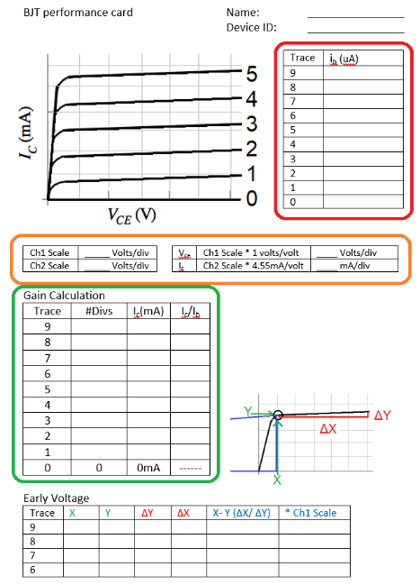

Figure : The BJT Performance card you will complete for every DUT. Text will be colored red, orange, or green when it describes how to fill in the BJT Performance Card table circled in that color.

By filling in this information you have taken the first step in computing the Gain Calculation table outlined in green. Let’s see what other information is need to collect and compute in order to complete the Gain Calculation table.

Start by powering the BJT Curve Tracer with 9V from a lab power supply. Next, you will need to setup your oscilloscope as shown in the following table. Note, you may need to make adjustments to this configuration depending on the DUT.

|  |  |
| --- | --- |
| Horizontal (scale) | 5 ms |
| Ch1 probe | CH_X |
| Ch1 (scale) | 0.5V/div |
| Ch 1(position) | Lowest visible reticule |
| Ch2 probe | CH_Y |
| Ch2 (scale) | 0.2V/div |
| Ch 2(position) | Lowest visible reticule |
| Trigger mode | Auto |

Finally connect the test BJT to the DUT socket.

You should see a rather chaotic set of waveforms as those shown in Figure 11 with activity on both channels. If either channel has no signal, make sure the DUT is firmly inserted into the test fixture or check if the DUT is inserted backwards. (Some BJTs have the collector and emitter terminals swapped.) Adjust the ground reference of both channels to the lowest visible reticule.

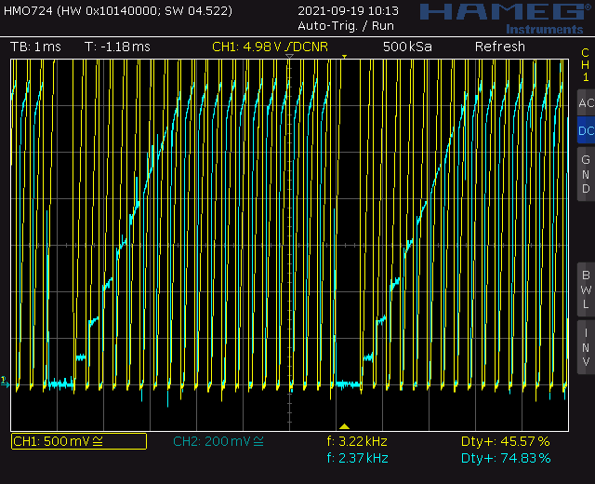

Figure : The oscilloscope output with a DUT in normal mode.

Next, you will need to put the oscilloscope into X/Y mode. Find the **Horiz** button and then use the softkey menu to select X/Y. (See Figure 12.)

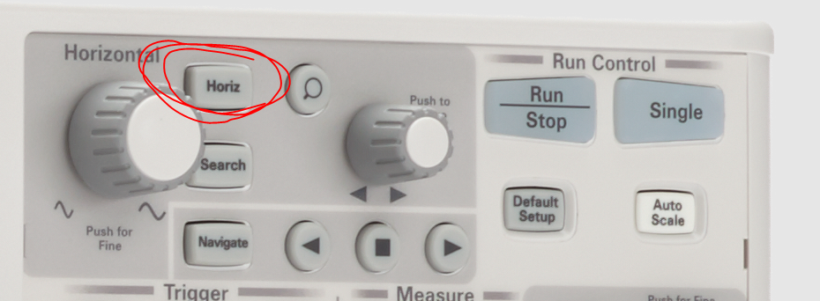

Figure : Display showing the placement of the Horiz button.

You should see something similar to Figure 13. You may adjust the Ch 1 and Ch 2 scale to make the family of curves fill the occupied space on the screen. Adjust the Ch 1 and Ch 2 offset so that the lower left corner of the family of curves is at the intersection of the lowest, left visible reticule. I will refer to the lower-left corner of the family of curves as the **origin**.



Figure : The BJT family of curves for the DUT. Try hitting the Run/Stop button on the oscilloscope to improve the image quality.

Congratulations, you have your BJT curve tracer working! Let’s figure out how to get numerical information from the plot to complete the Gain Calculation portion to the BJT Performance Card.

**Gain Calculation**

The following text will be color coded red, orange, or green when it refers to one of the circled areas in Figure 10. The data in this section will be a combination of the information contained in Figure 13 and the base currents found in Table 2. Your values will be different.

1. Fill in the orange circled area of Figure 10 with the scale you set on your oscilloscope. For example, in Figure 13 you should fill in 0.5V for the Ch 1 Scale and 0.2V for the Ch 2 scale.
2. Next, multiply the scale values from your oscilloscope by the respective constants to get the volts/div or mA/div. For example, in Figure 13 you should fill in 0.5 Volts/div for the Ch 1 and 0.9mA/div for the Ch 2.
3. Now, you need to fill in the green-circled area to determine the collector current for each of the curves. You will do this by estimating the height of each curve and fill in this information in the **#Divs** column. It should be clear by looking at Figure 13 the curves are not perfectly horizontal; they slope upwards. This slope makes it difficult to determine where to measure the height of the curve, so here is a heuristic. Measure the height of the curve at *Vce =* 1V (2 division to the right of the origin in Figure 13) in divisions.

Table : The Gain Calculation table filled in using the information from Figure 13. These gains have very good agreement. Do not be concerned if your values exhibit more variation.

|  |  |  |  |
| --- | --- | --- | --- |
| **Trace** | **#Divs** | ***ic*** | ***ic / ib*** |
| 9 | 4.3 | 3.9 | 250 |
| 8 | 4.2 | 3.8 | 250 |
| 7 | 3.6 | 3.2 | 241 |
| 6 | 3.2 | 2.9 | 254 |
| 5 | 2.7 | 2.4 | 258 |
| 4 | 2.1 | 1.9 | 257 |
| 3 | 1.5 | 1.4 | 255 |
| 2 | 1.1 | 1.0 | 278 |
| 1 | 0.4 | 0.36 | 240 |
| 0 | 0 | 0mA | -------- |

Next,

1. Fill in the collector current column, *ic,* by multiplying the value in the **#Divs** column by the Ch 2 value (using Equation 5).
2. Round your answers to 2 significant figures.
3. Finally, fill out the *ic / ib* column, the gain of the DUT, by dividing each traces collector current by its associated base current.

Congratulations, you have calculated the gain of your DUT! Most likely, you will get different gain values for different base currents, as is expected. Asking for a single value of gain across a variety of base currents is pointless because the gain of a BJT has a weak dependence on the collector current. You can look in a BJT datasheet and verify this for yourself. So, we have to be satisfied with the values in our Gain Calculation table and hope that they show some agreement.

Now, let’s turn our attention to the annoying slope that made measuring the collector current difficult.

**Early Voltage**

If you extend the flat portion of the highest curves in Figure 13 to the left, the line would interest the horizontal axis. Since the horizontal axis represents voltage, this intercept is a voltage, called the Early Voltage by analog designers. The Early Voltage area of the BJT Performance Card will assist you in calculating this voltage. Let’s see how to fill it in using the data in Figure 13.

We will examine Trace #7 in Figure 13 to explain how you will compute the Early voltage for your DUT. In the active region, Trace #7 is a straight line sloping upwards. Use the cursor function and align the X1 and Y1 cursors at the left end of the active region, where the curve is flat. Next align the X2 and Y2 cursors on the right end of the active region. You can use the X1 and X2 flags at the bottom of the screen and the Y1, Y2 flags on the right side of the screen to interpret the values shown on the right-side menu of the oscilloscope display.

Table : The Ealy Voltage table partially filled in using the data from Figure 13.

|  |  |  |  |  |  |  |
| --- | --- | --- | --- | --- | --- | --- |
| **Trace** | **X1** | **Y1** | **ΔY** | **ΔX** | **X-Y (ΔX/ ΔY)** | **\*Ch 1 Scale** |
| 9 |  |  |  |  |  |  |
| 8 |  |  |  |  |  |  |
| 7 | 0.225 | 0.71 | 0.1 | 4.21 | -29.7V | -------------- |
| 6 |  |  |  |  |  |  |

The Early Voltage is given by the value in the **X-Y (ΔX/ ΔY)** column. The **\*Ch 1 Scale** column is useful for oscilloscopes which do not have a cursor function. In this case, you would need to count divisions to make the Early Voltage computation and consequently need to multiply by the Ch 1 scale factor. Do not fill in this column if you use the cursor function.

# Turn In:

Make a record of your response to numbered items below and turn them in to Canvas using the instructions posted there. While you can work together to answer the questions in this lab document, this is an individual assignment. Thus, everyone is expected to turn in their own document.

**Oscilloscope in X/Y Mode**

Completed Figure 3.

Completed Table 1.

**Axis Scale for BJT Curve Tracer**

Completed Table 2.

**Completing the BJT Performance Card the BJT**

Complete a BJT Performance Card for the 2N3904 or 2N2222 BJT.

Complete a BJT Performance Card for the BD139 or TIP41C BJT.

Complete a BJT Performance Card for some other NPN BJT you find in the lab. As a first step, find the device datasheet. From this datasheet:

* + Determine the pinout for the Base, Emitter, and Collector.
  + Find the DC gain at the collector current around the values in Table 3.
  + Compare your calculated gain to the datasheet gain.